# Lab 07 – Jenkins build Pipeline and webhooks

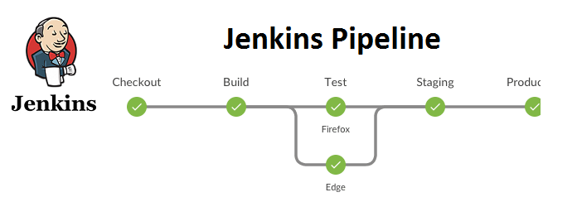

**Prerequisites**

* Required installed java version 8,9 ,10 or 11
* Jenkins installation on your local machine
* Refer **Week-06** for Jenkins Installation and sample Jenkins job creation using pipeline ( )

**Steps**

1. Login to Jenkins
2. Create Jenkins Job Name **Week07-YourStudentID** and choose project type **pipeline** and press OK. **Note**: Put you student id

1. Paste given description into description box

***Week 07 Jenkins Pipeline project to demonstrate GitHub, Maven and Jenkinsfile pipeline example***

1. Use github project <https://github.com/pritamworld/java-maven-ci-example>

1. In the pipeline sections
   1. Select Definition “Pipeline script from SCM”

* 1. Select SCM as “git”

1. Copy git repo as below and branch as master

<https://github.com/pritamworld/java-maven-ci-example.git>

1. As Script path write **jenkins/Jenkinsfile-windows** for windows user and **jenkins/Jenkinsfile-macos** of linux or macOS user

At the end you project looks like as below

1. Press Save and **Press Build** from left menu

1. After successful execution it will look like below screen

1. Submit Document file containing Screens of your project having file name **Week07_Lab_Exercise_StudentID.docx**
2. **Troubleshooting Installing Git and Maven on Jenkins if fails**
3. To Setup Git Path follow given steps

Go to Manage Jenkins

2) Select Global Tool Configuration

3) Set Git path

4) Set Maven installation

**5) Setting JAVA_HOME path**

**- Go to Manage Jenkins**

**- Select Configure System**

**- Add environment variable under Global properties**

**- Add JAVA_HOME variable with you java installation location**

**Jenkins/Jenkinsfile-\***

